Website Edits
I am using this website and a baseline because I feel this is done well (minus the amount of content). You can use this as well as a reference to build the website - https://www.turtlebalance.com/home

Font
Can we use the same fonts as used in the previous website?
Title - Alta
Subtitle - Glacial Indifference (bold)
Heading - Glacial Indifference
Content - Glacial Indifference

Tabs
Home
About Me
Services
How it works
FAQs
Contact
Search button —> 

Credentials
Pallavi Bhaskar
Education: MA - Psychology, PGDM
Certifications: Trauma Therapy - Trained in Internal Family Systems (IFS), CBT Practitioner, NLP Practitioner & Level 1 Life Coach, QPR Trained Crisis Counsellor

Contact Me
This section can use a WhatsApp icon and email icon that is hyperlinked.
Whatsapp: +91 9108694332 / https://wa.me/message/EIF2EASB2GEXI1
Email: therapy.icp@gmail.com
Example - 
The bottom of the page can look like this
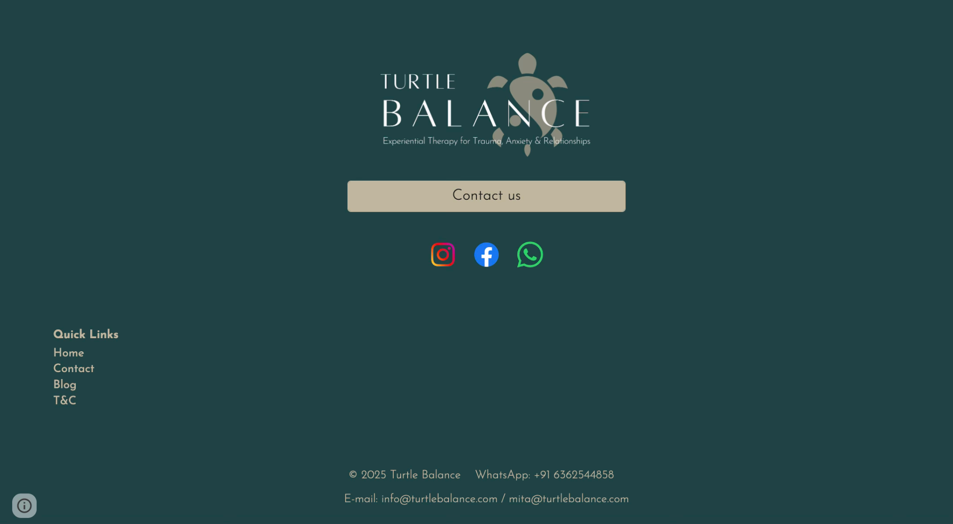

Share a the journey/ how it works in a pictorial flow// Dadda’s feedback, make it animated
Sharing an example from my previous website, but I am open to an enhanced/ better version -
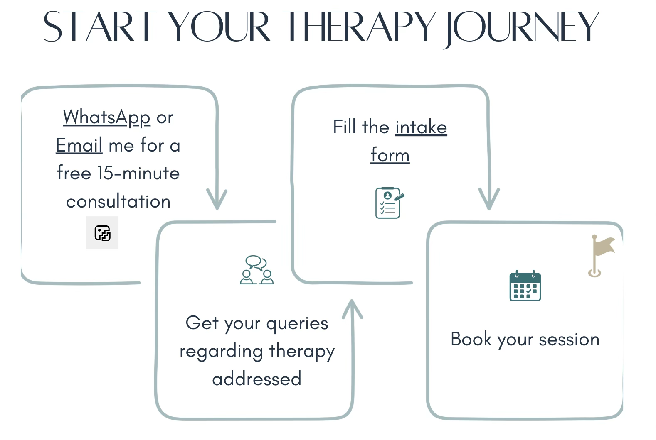

After showing the flow, we can show the book a free 15-minute consultation button along with the contact information.
Hyperlink to cal.com link wherever we place the 15min consultation buttons — https://cal.com/therapywithpallavi

Crisis Support
Please remove these two from the crisis support section -

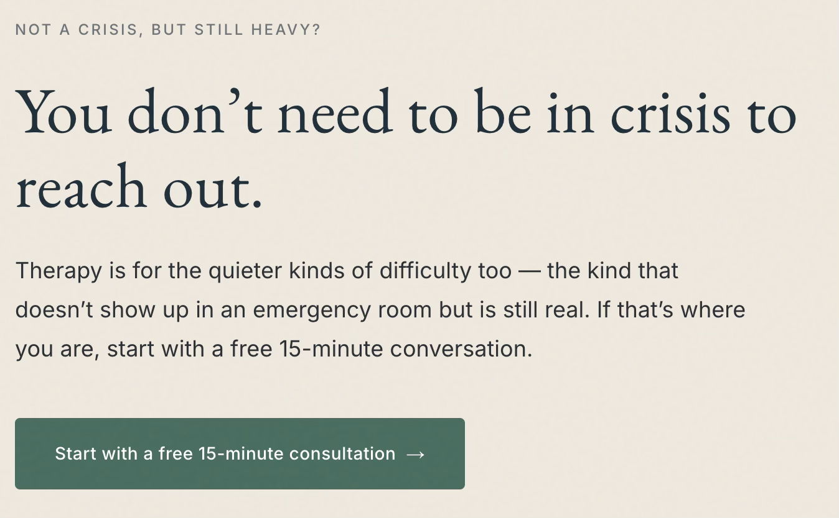

‘Home’ page
1. Please remove this text from the cover page -

2. Revised cover page content -
Headline:
A space to understand yourself — and move forward with clarity.
Sub-headline:
Compassionate, evidence-based therapy to help you navigate challenges, build self-awareness, and create meaningful change.
3. Please include an appropriate photo that syncs with the above description.
4. Include the 15-min consultation button with the writing/ description -
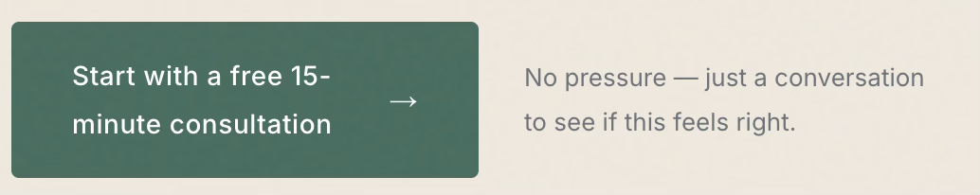
5. Remove this -
I’m Pallavi Bhaskar, a Counsellor and Psychotherapist with 8+ years of professional experience, including 4+ years in therapeutic practice.

‘About' Section
1. Change the name from ‘About’ to ‘About Me’
2. Start with my photo, name and credentials -
Eg. 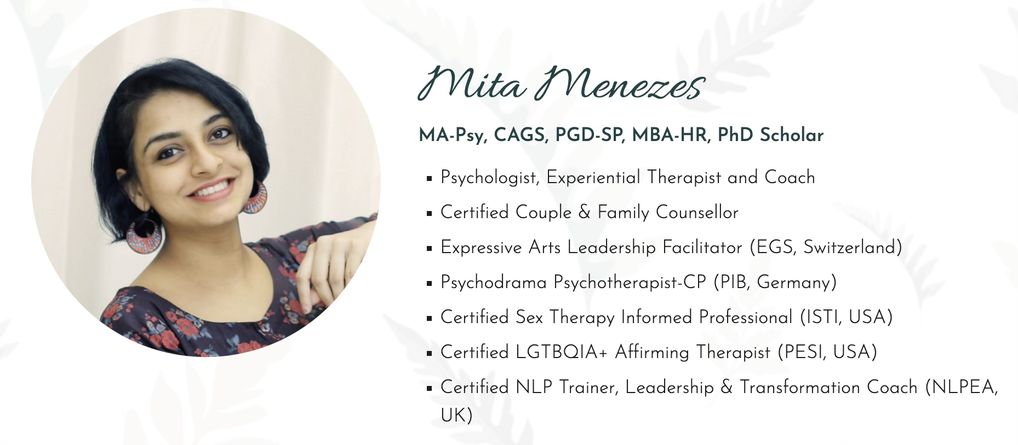
3. My description (please replace the earlier content with this one) -
My Background & Training
I hold a Master’s degree in Clinical Psychology and am trained in multiple evidence-based approaches, including Internal Family Systems (IFS), Cognitive Behavioural Therapy (CBT), Neuro-Linguistic Programming (NLP), and the Gottman Method.
I am trauma-trained, neurodiversity-affirmative, and follow a strength-based approach, which means:
- We move at a pace that feels safe and respectful
- Your experiences are understood in context, not judged
- We build on your existing strengths while working through challenges

Experience
I bring over 8 years of professional experience, including 4+ years in therapeutic practice, and have worked with 200+ clients. My work spans individuals across different life stages (20 years to 50 years of age) — from young adults navigating transitions to working professionals managing stress, relationships, and personal growth.
Before moving fully into therapy, I spent time in the corporate space — an experience that continues to inform my understanding of workplace stress, burnout, and the emotional demands of high-functioning environments.
I have also worked with organisations through workshops and consultations focused on mental health, emotional wellbeing, and workplace resilience.
How I Work
I offer a confidential space that is warm, non-judgmental, and grounded — where you can slow down, feel understood, and begin to make sense of your experiences.
My work is both reflective and practical. We start by understanding your patterns and inner world, and gradually build ways of responding that support clarity, stability, and meaningful change.
What I Help With
I work with adults navigating:
- Trauma - childhood, adulthood
- Anxiety, overthinking, and emotional overwhelm
- Low self-esteem and self-doubt
- Relationship challenges and boundary-setting
- Burnout and workplace stress
- Grief, transitions, and difficult life phases
- Patterns shaped by past experiences
While these concerns may appear different, they are often connected through deeper emotional patterns.
My work is trauma-informed, which means we approach these patterns with care, and at a pace that feels manageable. Clients often begin to experience greater clarity, emotional steadiness, and a deeper understanding of themselves over time.
Working Across Contexts
II work with clients across India and internationally, including NRIs and expats.
Many of the individuals I support are navigating the intersection of:
- Personal needs and family expectations
- Cultural identity and independence
- Belonging across different environments
Therapy becomes a space to explore these layers with nuance, while staying grounded in your individual experience.
Therapy Approach
My approach is integrative, trauma-trained, and person-centred.
This means:
- We move at a pace that feels right for you
- Each session is tailored to your needs
- We focus on understanding patterns before trying to change them
- We combine insight with practical tools over time
- The process is collaborative — not prescriptive
You won’t be rushed, and you won’t be pushed beyond what you’re ready for.
At the same time, I will gently guide you and support you in staying accountable to your own growth.
Note: I offer counselling and psychotherapy services focused on emotional wellbeing and personal growth. I am not a psychiatrist and do not prescribe medication. For clinical diagnosis, medication, or severe mental health concerns, I may recommend consulting a clinical psychologist or psychiatrist, and I’m happy to guide you toward appropriate support if needed.

Other Notes
Please remove the descriptions written under all the photos -
Example -


